Section 5. Basic Parts of a Computer
Directions: Use the Internet or the website: www.gcflearnfree.org/computers/computerbasics.
Label each part and write a short sentence about it.
Name:_________________________________________
Purpose:______________________________________________________________________________________
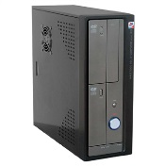

Name:_________________________________________
Purpose:______________________________________________________________________________________
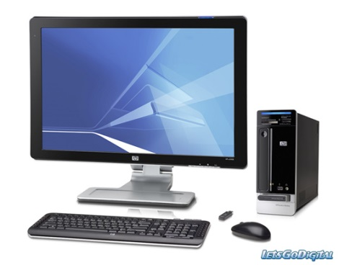
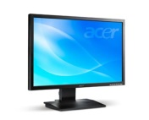

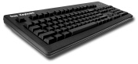
Name:_________________________________________
Purpose:______________________________________________________________________________________

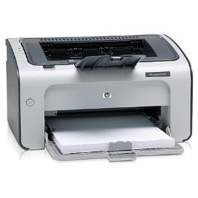
Name:_________________________________________
Purpose:______________________________________________________________________________________

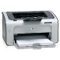
Name:_________________________________________
Purpose:______________________________________________________________________________________

Fill In the Blank
Use the lesson, “Basic Parts of a Computer” on www.gcflearnfree.org/computers/computerbasics
The __________________________is the metal and plastic box that contains the main __________________of the computer. It houses the___________________, central processing unit (_________), ________________________, and more.
Computer cases come in different ____________and ____________. A ____________ case lies flat on a desk, and the ____________ usually sits on top of it. A ____________ case is tall and sits next to the monitor or on the floor. The ____________ of the case usually has an on/off switch and one or more ______________________.

Answer in complete sentences
- What component located inside the computer case allows the monitor to display images and text on the screen?
___________________________________________________________________________________________

- What can you use to protect your computer from voltage spikes?

______________________________________________________________________________________________________________________________________________________________________________________________

- How is an optical mouse different from a mechanical mouse?
______________________________________________________________________________________________________________________________________________________________________________________________

- What is a touchpad?

______________________________________________________________________________________________________________________________________________________________________________________________
______________________________________________________________________________________________

