Section 4. What is the Cloud?
Fill in the Blanks
You may have heard people using terms like the cloud, cloud computing, or _____________________. But what exactly is the cloud? Basically, the cloud is____________________—more specifically, it's all of the things you can ____________________________ over the___________________. When something is in the cloud, it means it is stored on _____________________on the Internet instead of on your_____________________. It lets you access your calendar, email, files, and more from any __________________ that has an Internet_____________________.
If you've ever used web-based___________________, you've used the________________. All of the emails in your inbox are stored on_____________________. However, there are many other services that use the cloud in different ways.
Answer in complete sentences
- Write a brief description for the following web-based services that use the cloud.
  - Dropbox:________________________________________________________________________________
___________________________________________________________________________________________
  - Evernote:________________________________________________________________________________
___________________________________________________________________________________________
  - Mozy:__________________________________________________________________________________
___________________________________________________________________________________________

- Explain why computer users should use the cloud?
______________________________________________________________________________________________________________________________________________________________________________________
______________________________________________________________________________________________________________________________________________________________________________________

- How is a web app different from a desktop application??
______________________________________________________________________________________________________________________________________________________________________________________
______________________________________________________________________________________________________________________________________________________________________________________

- Do you use any apps or websites now that you think are cloud-based? If so, what do you use?
___________________________________________________________________________________________
___________________________________________________________________________________________
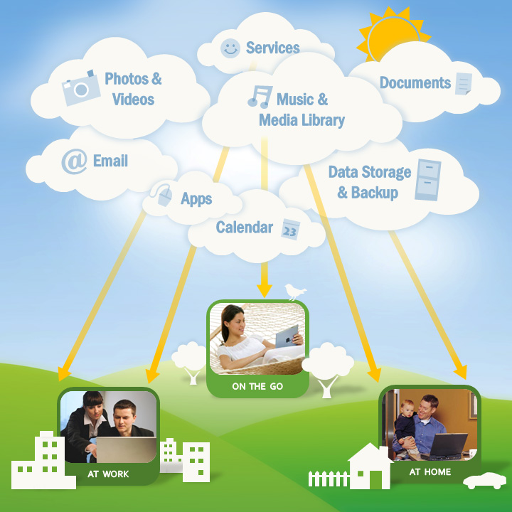

If you've ever used web-based email, you've used the cloud. All of the emails in your inbox are stored on servers.

