Digital Law 3 – Q3 Plagiarism

ASSIGNMENT

Steps:

1. Visit http://www.biography.com/people/martin-luther-king-jr-9365086 to find information on Martin Luther King Jr.

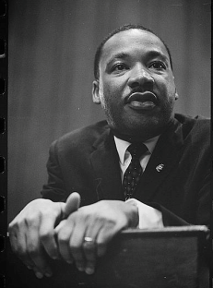 Martin Luther King Jr. Photographed by Marion S. Trikosko, 1964. LC-DIG-ppmsc-01629 Source: Library of Congress

2. Copy the synopsis

3. Now let's check this information for original content

4. Visit http://www.paperrater.com/plagiarism_checker and paste the copied content into the text box. Agree to the terms of service by checking the box and then click on get report

5. When results are completed, take a screen shot of the results box

6. In a word processing program or blog reflect on the following questions:

a. Show the percentage of originality by pasting the screenshot and reflect on what the results tell you?

b. Now find a document you have created and check it for plagiarism using the PaperRater. Show the percentage of originality by pasting the screenshot (in same word doc as above) and reflect on what the results tell you. Do you have any original content or have you possibly copied some from the Internet?

c. Now that you have checked two documents for original content, add a paragraph to your current document on why sites such as PaperRater exist and why it could benefit you in the future?

Adapted from: http://www.21things4students.net/21/be-legal--fair/q2-the-source/

