INFORMATIVE WRITING - escritura informative, realidad
Instructions: Type the following text and add a picture in the frame, below the dotted line.
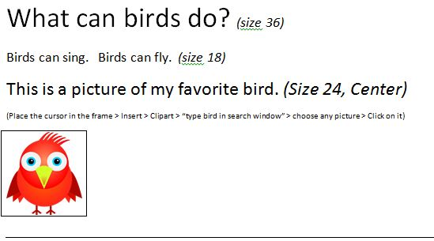

W
B
T

