OPINION WRITING - escritura opinion, sentimiento
Instructions: Type the following text and add a picture in the frame, below the dotted line.
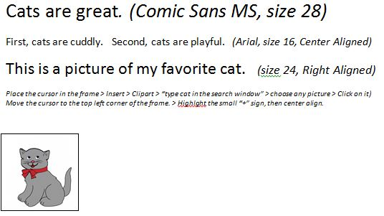
--------------------------------------------------------------
C
F
T

