NARRATIVE WRITING - Escritura narrative, Narración de cuentos
Instructions: Type the following text, add pictures and resize them in the spaces as shown. Use your name. Align your sentences as shown below. Your story must fit in the space.
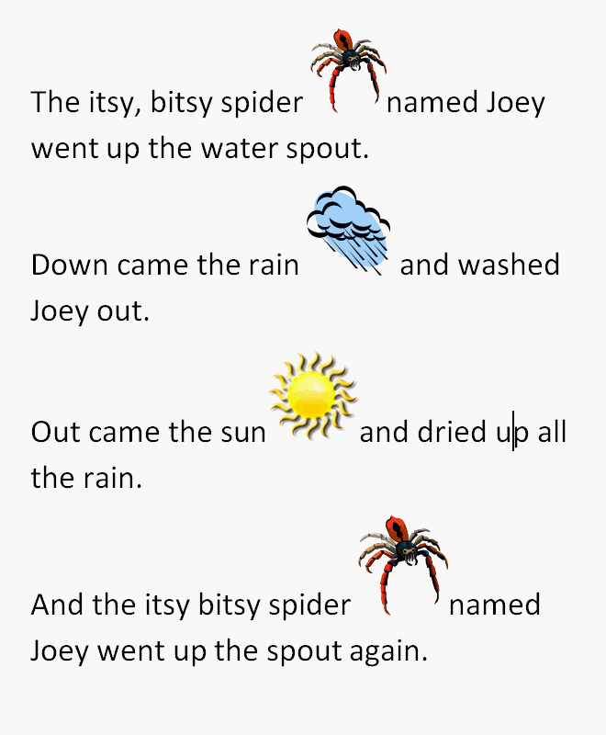
Left Align

Center Align

Right Align

Justified

