Proper Computer Ergonomics
Directions - : Label the diagram below with helpful hints on how to sit at a
computer using proper ergonomics.

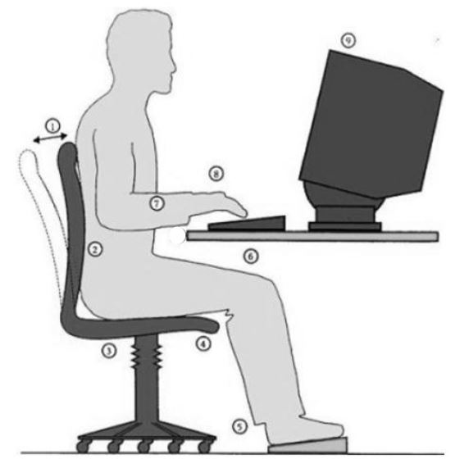
[Type a quote from the document or the summary of an interesting point. You can position the text box anywhere in the document. Use the Drawing Tools tab to change the formatting of the pull quote text box.]

1
2
3
4
5
6
7
8
9
10

Source: http://www.leeds.ac.uk/lsmp/healthadvice/computerergonomics/computergonomics.htm

