# Section 1 – [What’s Inside a Computer?](http://www.egusd.net/franklinhs/techstandards/Computer%20Tech%20Files/Computer%20Basics%20Standard/What%20is%20Inside%20a%20Computer.pdf)

***Click on the link above (hold down the Ctrl key and click) and review the power point. After reading the material answer the questions below about each components responsibility. Fill in the blank with the correct answer from the box. Some may be used more than once or not at all.***

**CPU BIOS power supply hard drive network card**

**Motherboard RAM USB Port ROM video card**

1. I connect computers and allow them to talk to each other.
2. I wake up the computer and remind it what to do.
3. I am the brain of the computer.
4. Information is stored on my magnetic cylinders.
5. I hold all of the other circuit boards.
6. I handle the graphics that are displayed on the monitor.
7. I am the type of port used by flash drives

# Section 2 - [Storage](http://www.egusd.net/franklinhs/techstandards/Computer%20Tech%20Files/Computer%20Basics%20Standard/Storage.pdf)

***Click on the link above (hold down the Ctrl key and click) and review the power point. Fill in the blanks with the vocabulary words from the box. Use each word only once. You may want to refer back to the vocabulary list that was given above.***

**Information flash drive CD primary DVD secondary**

1. ________________________________ memory is stored on chips located on the motherboard.

2. ________________________________memory is stored on the hard drive.

3. A ________________________________can hold information greater than a CD or DVD.

4. A ________________________________usually holds up to 650 to 700 MB.

5. A ________________________________holds even more information at least 7 GB.

6. The purpose of storage in a computer is to hold ­ ________________________________or data.

# Section 3 - [Programs](http://www.egusd.net/franklinhs/techstandards/Computer%20Tech%20Files/Computer%20Basics%20Standard/Programs.pdf)

***Click on the link above (Programs) and review the power point. After reading the material answer the questions below about each components responsibility.***  ***Fill in the blank with the correct answer from the box. Some may be used more than once or not at all.***

**Research Spreadsheet Database**

**Entertainment Desktop Publishing Word processing**

1. Creating a birthday card for a friend. ________________________________
2. Balancing your checkbook. ________________________________
3. Finding information on pyramids. ________________________________
4. Playing solitaire. ________________________________
5. Calculating Math ________________________________
6. Keeping an address book. ________________________________
7. Writing an essay. ________________________________
8. Making a newsletter. ________________________________
9. Writing a story about aliens. ________________________________

# Section 4 - [Programs](http://www.egusd.net/franklinhs/techstandards/Computer%20Tech%20Files/Computer%20Basics%20Standard/Programs.pdf)

***Click on the link above (Vocabulary) and review the power point. After reading the materials answer the questions below.***  ***Fill in the blank with the correct answer from the box. Some may be used more than once or not at all.***

**downloaded translators installing programming program programmers**

1. A _____________________ is a set of instructions that tells the computer how to perform a specific task.
2. Programs are like _____________________ that allow people to work with computers without learning the computer’s language.
3. Using bits and bytes in different combinations to represent a code is known as  
   _____________________.
4. Copying a program onto your computer’s hard drive from another source is known as _____________________the program.
5. People who write codes to create programs are known as computer _____________________.
6. Some programs can be _____________________ from the internet directly to your hard drive

# Section 5 - [Operating Systems](http://www.egusd.net/franklinhs/techstandards/Computer%20Tech%20Files/Computer%20Basics%20Standard/Operating%20Systems.pdf)

***Click on the link above (Operating Systems) and review the power point. After reading the materials answer the questions below.***  ***Fill in the blank with the correct answer from the box. Some may be used more than once or not at all.***

**Windows operating system graphics upgraded user friendly**

1. The large program that controls how the CPU communicates with other hardware components is the ____ ______________
2. A computer that is easy to operate is called ____ ______________
3. ____ ______________is the most common operating system for PCs.
4. Operating systems are constantly being ____ ______________ as technology advances.
5. A Graphical User Interface (GUI) uses ____ ______________to help the user navigate within the computer system

# Section 6 - [Hardware Basics](http://www.egusd.net/franklinhs/techstandards/Computer%20Tech%20Files/Computer%20Basics%20Standard/HARDWARE%20BASICS.pdf)

***Label the parts by finding the diagram in the presentation link above.***

1)______________

2) _____________

3) _____________

4) _____________

5) _____________

6) _____________

7) _____________

8) _____________

9) _____________

10) ____________

11) ____________

12) ____________

13) ____________

14) ____________

Hard Drive

Sound

Power Supply

CD/DVD

CPU

Motherboard

BIOS

RAM

Video

USB

Network (NIC)

Graphics Port

Key Board

Mouse

A |O|O|

B |O|O|



**1**

**2**

**3**

**4**

**5**

**7**

**6**

**8**

**9**

**10**

**11**

**12**

**13**

**14**

# Section 7 - [System Requirements](http://www.egusd.net/franklinhs/techstandards/Computer%20Tech%20Files/Computer%20Basics%20Standard/System%20Requirements.pdf)

***Directions: New software always has a minimum system requirement. Meaning that the computer CPU, RAM, etc. has to be of a certain quality to run that program. Look at the sample below, then, look at each specification listed to determine whether or not it will support the software. Check “yes” if the specification meets the system requirements, or check “no” if it does not.***

**THE SOFTWARE’S MINIMUM SYSTEM REQUIREMENTS ARE:**

|  |  |
| --- | --- |
| *Windows 2000/XP*  *Pentium 333 MHz or faster* | *32 MB RAM or more*  *16x CD-ROM drive or faster* |
| *56 MB available hard disk space* |  |

**THEN WILL THE FOLLOWING SYSTEMS WORK?**

1. Yes No Windows XP, Pentium 333, 64 MB RAM, 150 MB free hard disk space, 24x CD-ROM.

2. Yes No Windows 98, Pentium 100, 8 MB RAM, 32 MB free hard disk space, 8x CD-ROM

3. Yes No Windows 2000, Pentium 333, 64MB RAM, 150 MB free hard disk space, 24x CD-ROM drive.

4. Yes No Windows XP, Pentium 4 (1.70 GHz), 256 MB RAM, 12 GB free hard disk space, 24x CD-ROM drive

**Section 8** - [The Windows Desktop](http://www.egusd.net/franklinhs/techstandards/Computer%20Tech%20Files/Computer%20Basics%20Standard/Windows%20Desktop.pdf)

***Click on the link above (The Windows Desktop) and review the power point. After reading the materials answer the questions below.***  ***Fill in the blank with the correct answer from the box. Some may be used more than once or not at all.***

**GUI icon Recycle Bin Start Menu task bar windows tool bar scroll bar wallpaper title bar**

1. You put things in the that you no longer need or want.
2. A uses graphics or pictures to help the user navigate and access programs.
3. The Start Menu and clock are found on the .
4. An is a small picture that links to a file or program.
5. At the top of each window, the contains the title and buttons to close, minimize and resize.
6. Moving the up or down allows you to see all of the information in a window.
7. Programs and applications run inside that can be opened, closed or resized.
8. The is like a backdrop on your desktop that can be changed.
9. Found below the menu bar in some windows, the contains icons or options that allow you to perform specific tasks.
10. The contains basic operations such as run, shut down, log off and find.

**Section 9 -** [**Organizing files and folders**](http://www.egusd.net/franklinhs/techstandards/Computer%20Tech%20Files/Computer%20Basics%20Standard/Files%20and%20folders.pdf)

***Click on the link above (The Windows Desktop) and review the power point. After reading the material, answer the questions below.***  ***Under each Program Name and folder, write the appropriate file name and extension.***

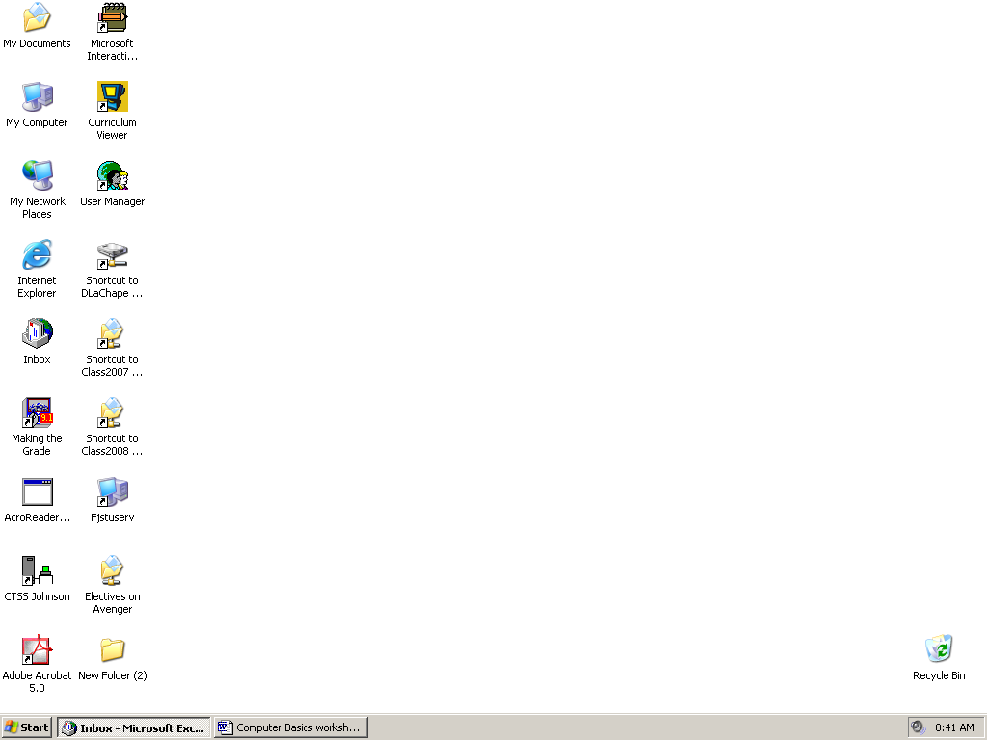

Excel



PowerPoint



Publisher



Word

**Organizing Files**

|  |  |  |
| --- | --- | --- |
| rentals.xlsx | brochure.pub | mla.docx |
| maze.pptx | gpa.xlsx | france.pptx |
| tabs.doc x | calendar.pub | card.pub |
| memo.docx |  |  |