Computers: The Windows Desktop Worksheet
Section 1: Fill in the blanks with the vocabulary words from the box below. Use each word only one time.

desktop GUI icon Recycle Bin
Start Menu Control Panel task bar title bar
Window tool bar scroll bar wallpaper

- You put things in the that you no longer need or want.

- A uses graphics or pictures to help the user navigate and access programs.

- The Start Menu and clock are found on the -------
- The is the background screen for all programs and contains the commands needed to access them.

- An is a small picture that links to a file or program.

- At the top of each window, the contains the title and buttons to close, minimize and resize.

- Moving the up or down allows you to see all of the information in a window.

- Programs and applications run inside that can be opened, closed or resized.

- The is like a backdrop on your screen that can be changed.

- Found below the menu in some windows, the -------
contains icons or options that allow you to perform specific tasks

- The contains basic operations such as run, shut down and find.

- The contains important system controls.

The Windows Desktop Labeling Sheet

Section 2: Fill in the blank areas with the correct answer

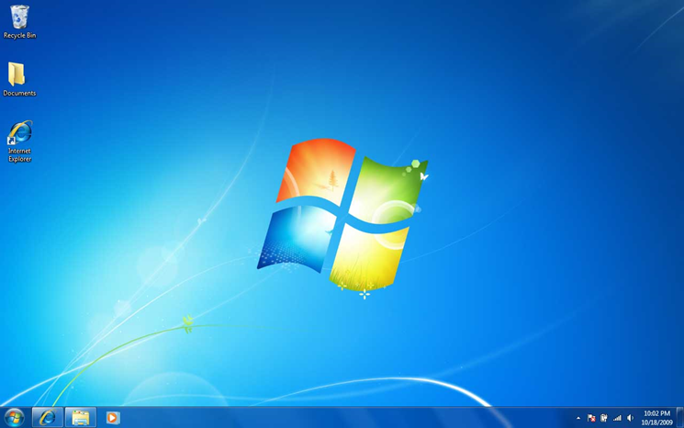

R____________________

Where you put things you no longer want

I

A small picture that links to a file or program

M___________________
Hidden windows, but applications still running and accessible.

T____________________

Includes the Start Menu and the Clock

W________________________

Backdrop (background pic) on the desktop

S_____________Button
Contains basic operations such as run, shut down, log off and find

